­­



Submitted to

:

Mam. Sadaf

***BS***

***-***

***Software Engineering***

***2***

***nd***

***-***

***E***

Title: Lab Report

OOP

Hamza Mehmood

Roll# SP-21-110

NUML

-

S21

-

2352

9



**National University of Modern Languages**

Object Oriented Programming

# Week 1 (27-9-2021)

Table of Contents

|  |  |
| --- | --- |
| S.no. | Programs |
| 1 | What is A Program? |
| 2 | Getting Started |
| 3 | Simple Java Application |
| 4 | First Program in Java |
| 5 | Simple Arithmetic  Short Hand  Increment & Decrement |
| 6 | Relational Operators  Logical Operators |
| 7 | Bitwise Operators |

What is A Program?

A **computer program** (also a software program, or just a program) is a sequence of instructions written to perform a specified task for a computer.

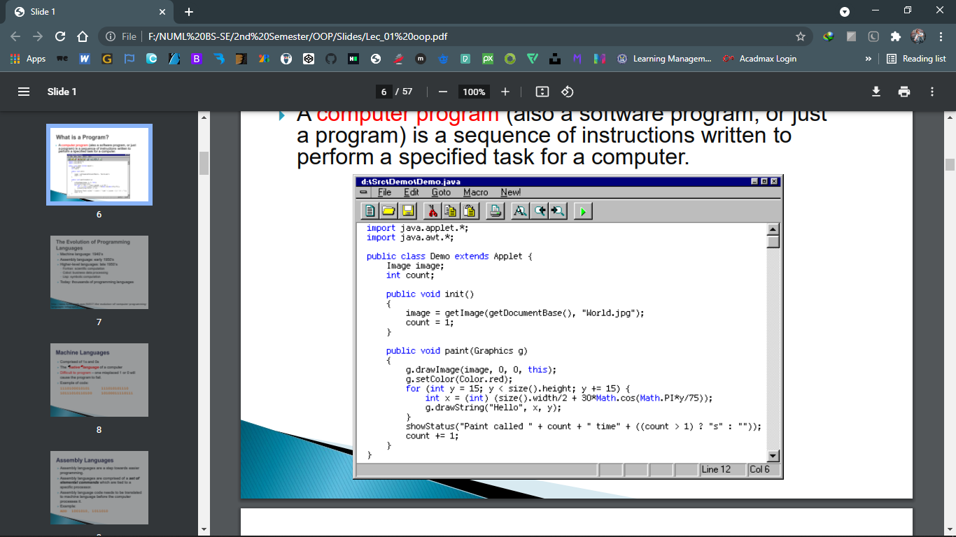

Getting Started

To begin developing Java programs, follow

these steps:

**Step 1**: Obtain the Software Development

Kit (SDK) for J2SE (Java 2 Platform,

Standard Edition) or JDK

**Step 2:** Install the JDK

Simple Java Application

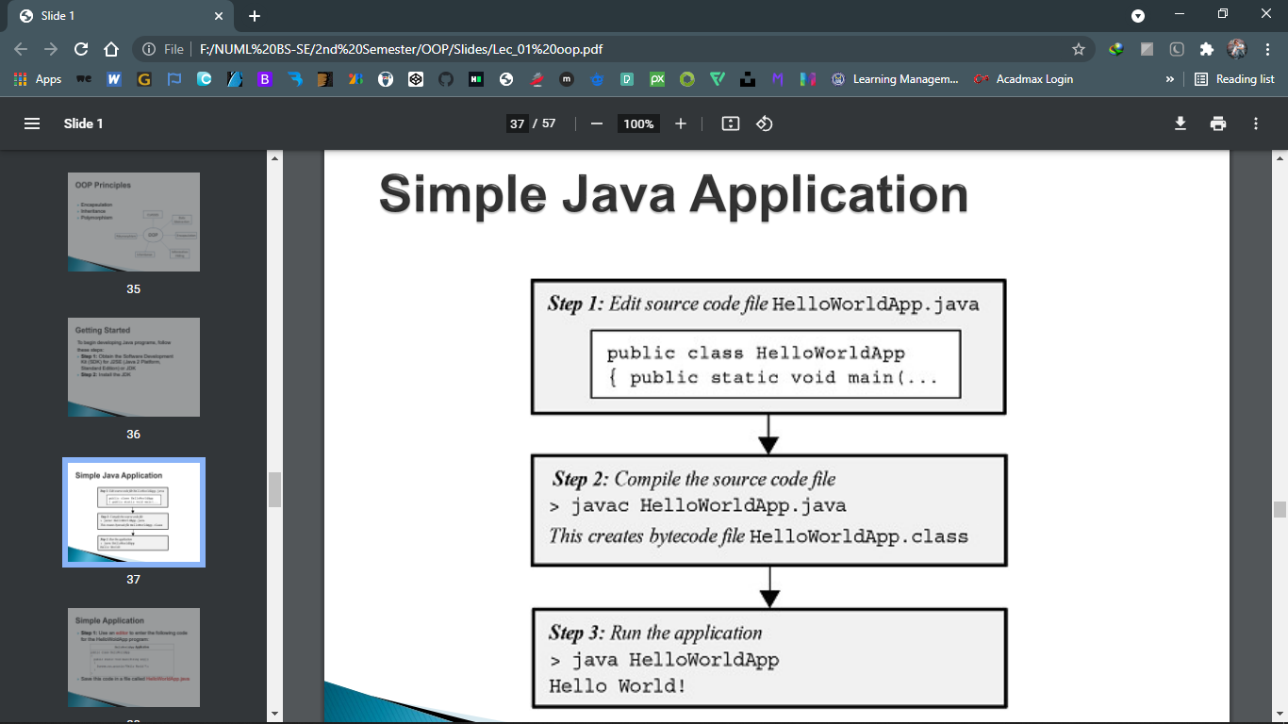

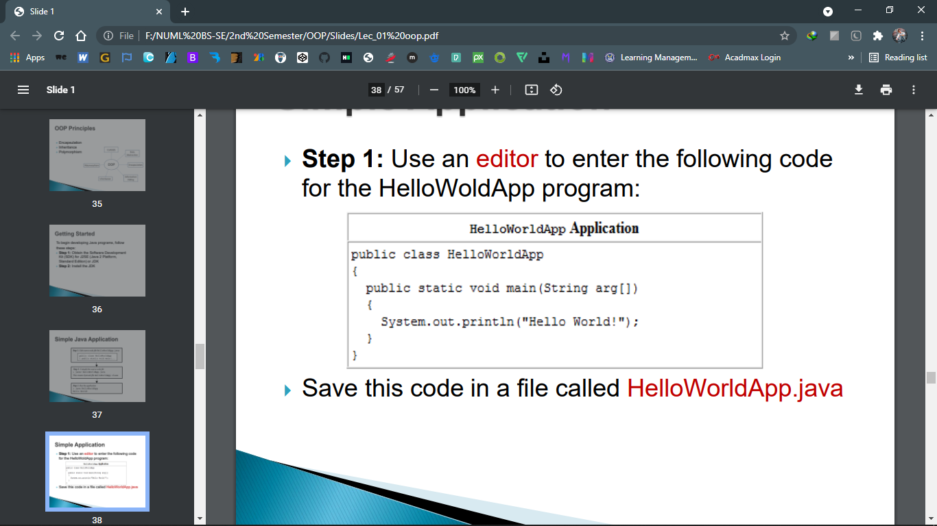

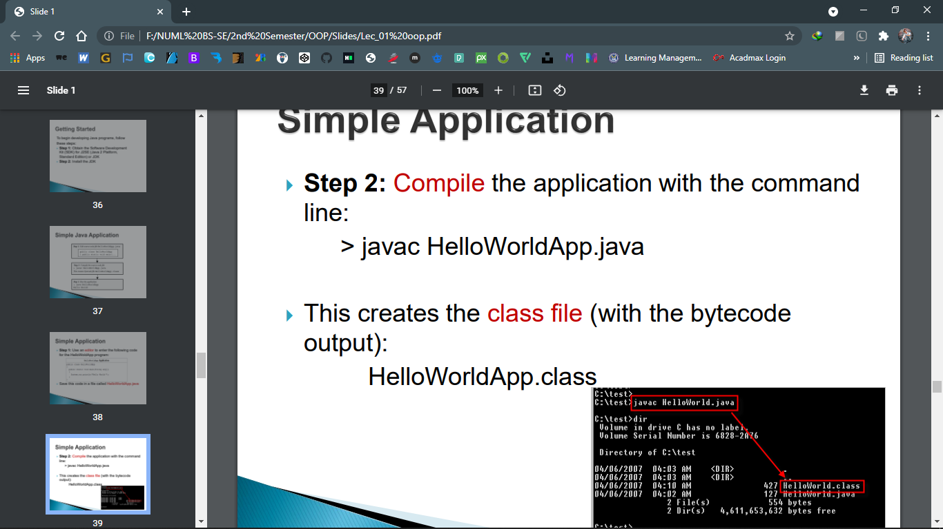

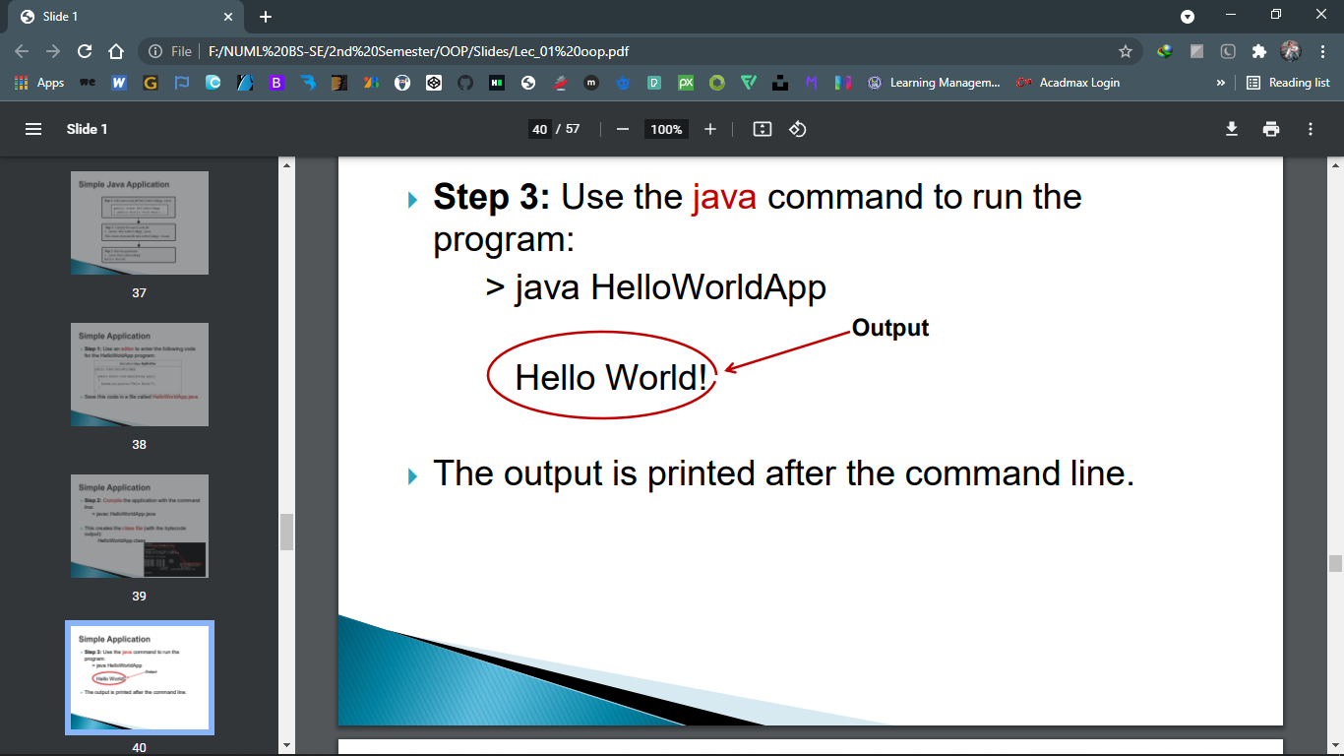

First Program in Java

public class HelloWorld {

    public static void main(String[] args) {

        System.out.println("Hello World");

    }

}

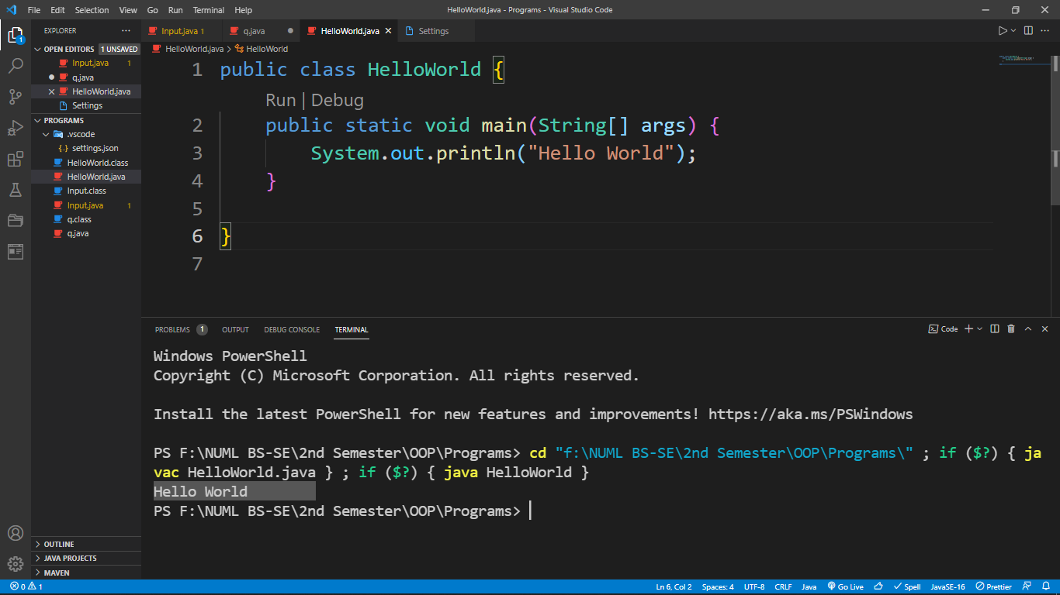Simple Arthimetic in Java

public class SimpleArithmetic {

    public static void main(String[] args) {

        int j, k, p, q, r, s, t;

        j = 5;

        k = 2;

        p = j + k;

        q = j - k;

        r = j * k;

        s = j / k;

        t = j % k;

        System.out.println("p = " + p);

        System.out.println("q = " + q);

        System.out.println("r = " + r);

        System.out.println("s = " + s);

        System.out.println("t = " + t);

    }

}

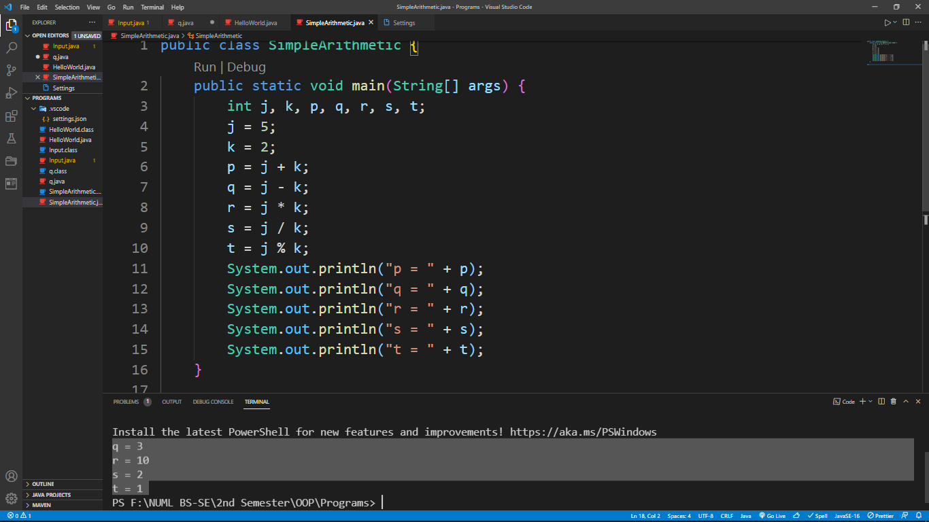Short Hand Operator

public class ShortHandO {

    public static void main(String[] args) {

        int j, p, q, r, s, t;

        j = 5;

        p = 1;

        q = 2;

        r = 3;

        s = 4;

        t = 5;

        p += j;

        q -= j;

        r *= j;

        s /= j;

        t %= j;

        System.out.println("p = " + p);

        System.out.println("q = " + q);

        System.out.println("r = " + r);

        System.out.println("s = " + s);

        System.out.println("t = " + t);

    }

}

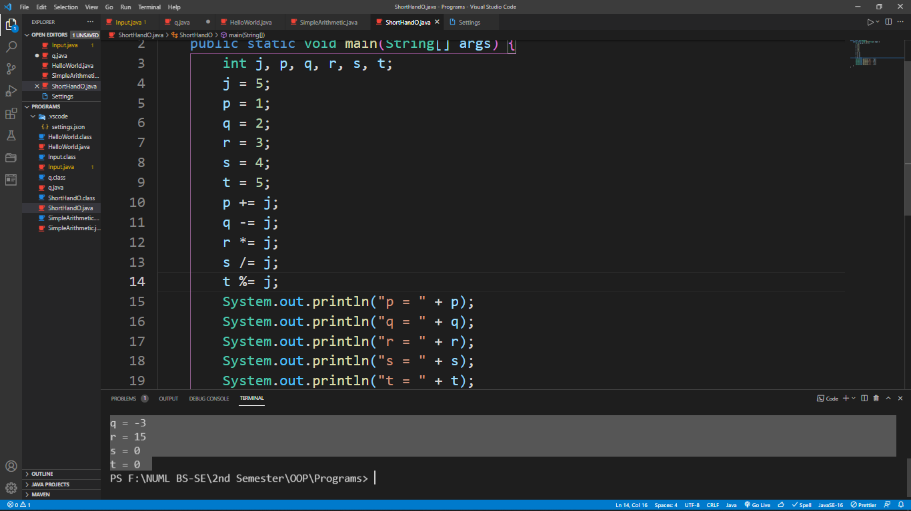Increment & Decrement

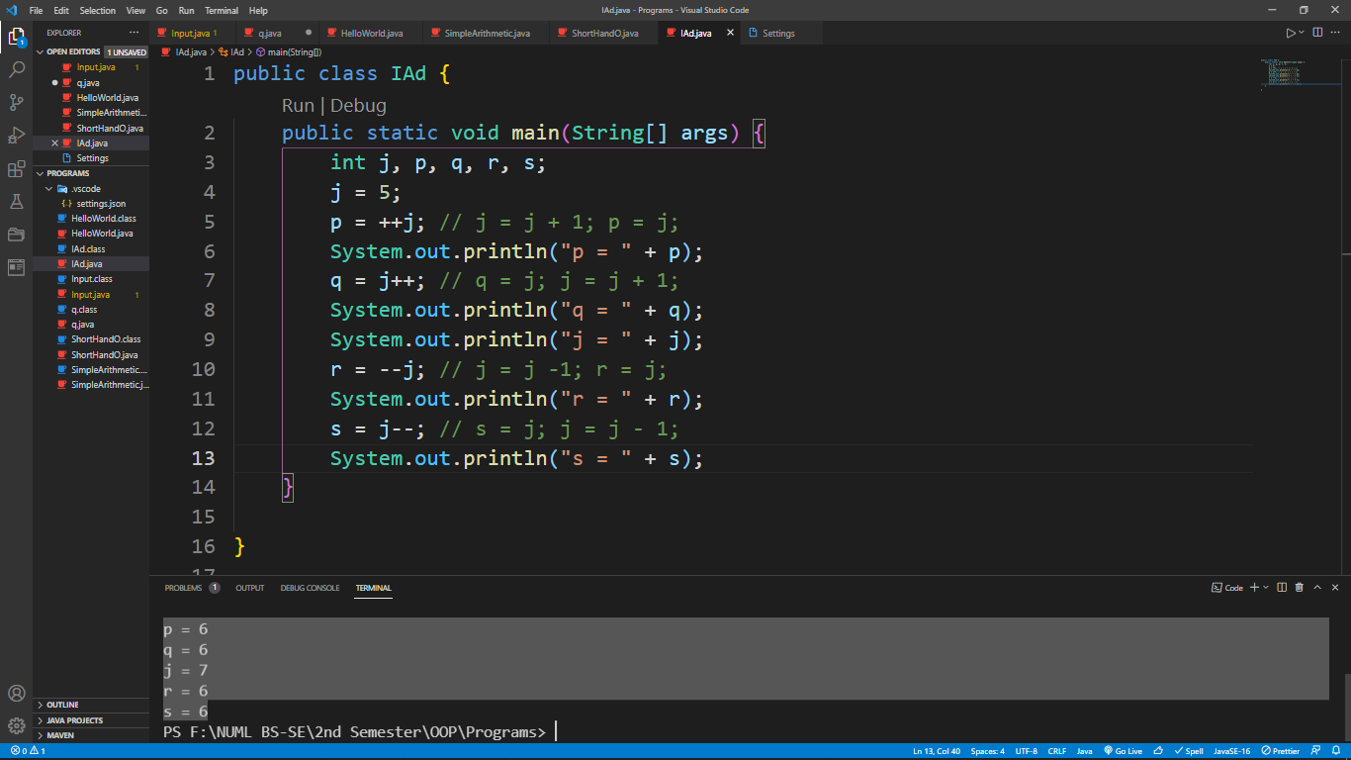

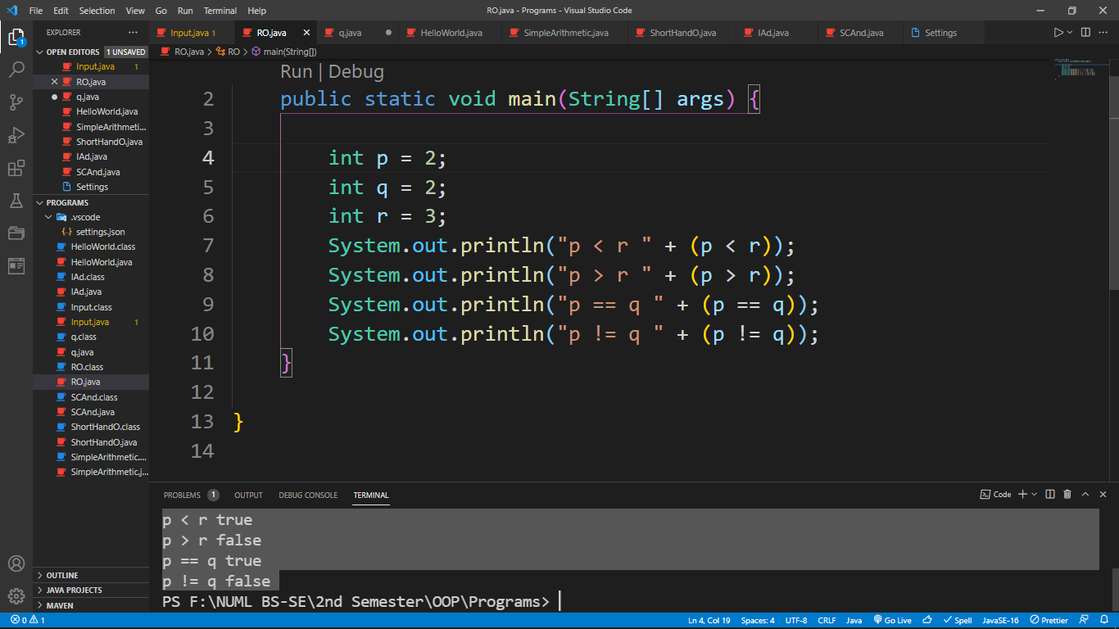Relational Operators

Logical Operators

public class LO {

    public static void main(String[] args) {

        boolean t = true;

        boolean f = false;

        System.out.println("f && f " + (f && f));

        System.out.println("f && t " + (f && t));

        System.out.println("t && f " + (t && f));

        System.out.println("t && t " + (t && t));

        System.out.println("f || f " + (f || f));

        System.out.println("f || t " + (f || t));

        System.out.println("t || f " + (t || f));

        System.out.println("t || t " + (t || t));

        System.out.println("!f " + !f);

        System.out.println("!t " + !t);

    }

}

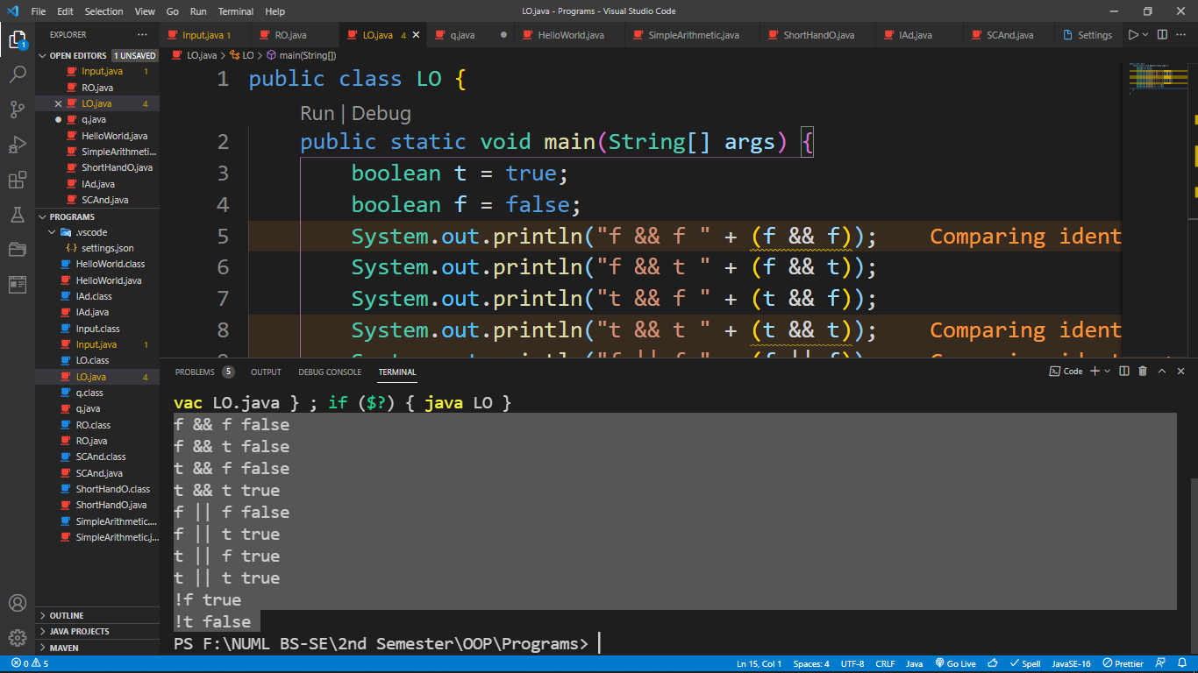

Logical BIT Operators

public class LBOperator {

    public static void main(String[] args) {

        int a = 10; // 00001010 = 10

        int b = 12; // 00001100 = 12

        int and, or, xor, na;

        and = a & b; // 00001000 = 8

        or = a | b; // 00001110 = 14

        xor = a ^ b; // 00000110 = 6

        na = ~a; // 11110101 = -11

        System.out.println("and " + and);

        System.out.println("or " + or);

        System.out.println("xor " + xor);

        System.out.println("na " + na);

    }

}

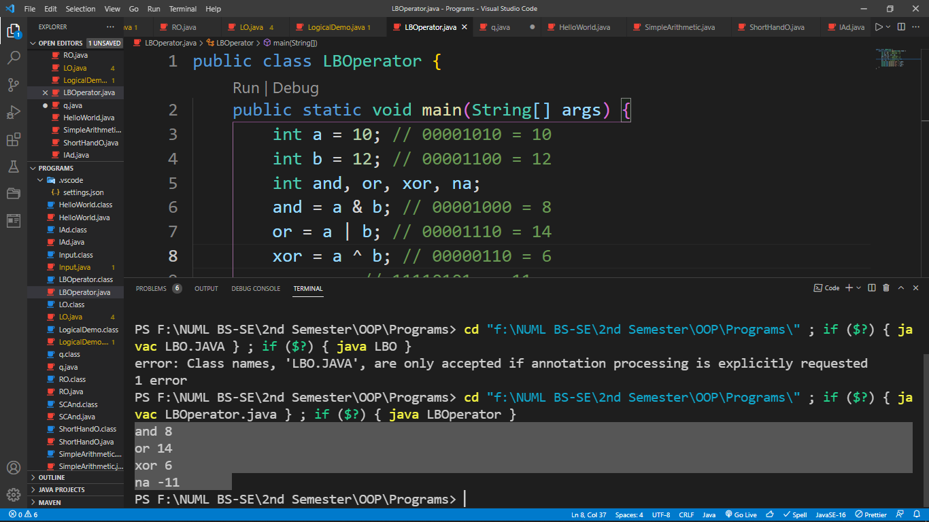

**National University of Modern Languages**

Object Oriented Programming

# Week 2 & 3

Table of Contents

|  |  |
| --- | --- |
| S.no. | Programs |
| 1 | Write a program to calculate the area of different shapes i.e. square, rectangle, circle by using classes |
| 2 | Write a program to get data of car class i.e. model, owner name, price and print these all for 2 objects. |

import java.util.Scanner;

// import java.util.Random;

class Rectangle {

    float Height;

    float Width;

    float Length;

    void Rectangle_area() {

        System.out.println("The area of Rectangle is" + (Height * Length * Width));

    }

}

class Square {

    float Width;

    float Length;

    void Square_area() {

        System.out.println("The area of Square is" + (Length * Width));

    }

}

class Circle {

    float pi = 3.14f;

    float Radius;

    void Circle_area() {

        System.out.println("The area of Circle is" + (pi * Radius * Radius));

    }

}

public class Shapes {

    public static void main(String[] args) {

        Scanner sc = new Scanner(System.in);

        Rectangle big = new Rectangle();

        System.out.println(" ");

        System.out.println("Enter Width for Rectangle");

        big.Width = sc.nextFloat();

        System.out.println("Enter Length for Rectangle");

        big.Length = sc.nextFloat();

        System.out.println("Enter Height for Rectangle");

        big.Height = sc.nextFloat();

        System.out.println(" ");

        System.out.println("Area of Rectangle");

        big.Rectangle_area();

        Square small = new Square();

        System.out.println("Enter Width for Square");

        small.Width = sc.nextFloat();

        System.out.println("Enter Length for Square");

        small.Length = sc.nextFloat();

        System.out.println(" ");

        System.out.println("Area of Square");

        small.Square_area();

        Circle round = new Circle();

        System.out.println("Enter Radius for Circle");

        round.Radius = sc.nextFloat();

        System.out.println(" ");

        System.out.println("Area of Circle");

        round.Circle_area();

    }

}

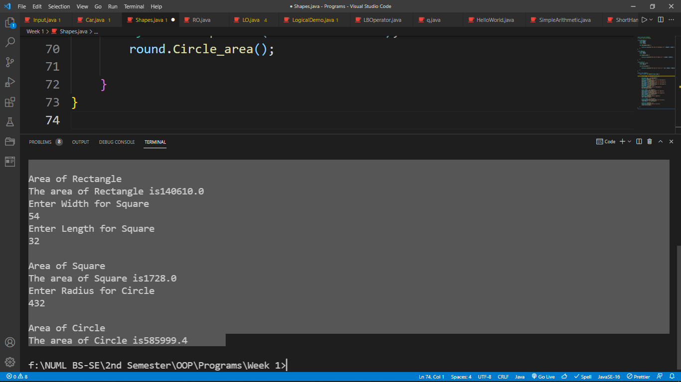OUTPUT

import java.util.Scanner;

class Car {

  int model;

  String car_name;

  int price;

  String owner;

  void detail() {

    System.out.println("Model: " + model);

    System.out.println("Car_name: " + car_name);

    System.out.println("Price: " + price);

    System.out.println("Owner: " + owner);

  }

  public static void main(String [] args) {

    Scanner sc = new Scanner(System.in);

    Car one = new Car();

    System.out.println("Enter Data for Car One");

    System.out.println("Enter MODEL");

    one.model = sc.nextInt();

    System.out.println("Enter Car name");

    one.car_name = sc.next();

    System.out.println("Enter PRICE");

    one.price = sc.nextInt();

    System.out.println("Enter Owner");

    one.owner = sc.next();

    Car two = new Car();

    System.out.println("Enter Data for Car Two");

    System.out.println("Enter MODEL");

    two.model = sc.nextInt();

    System.out.println("Enter Car name");

    two.car_name = sc.next();

    System.out.println("Enter PRICE");

    two.price = sc.nextInt();

    System.out.println("Enter Owner");

    two.owner = sc.next();

    System.out.println(" ");

    System.out.println("Data of car One is:-");

    one.detail();

    System.out.println(" ");

    System.out.println("Data of car Two is:-");

    two.detail();

  }

}

OUTPUT

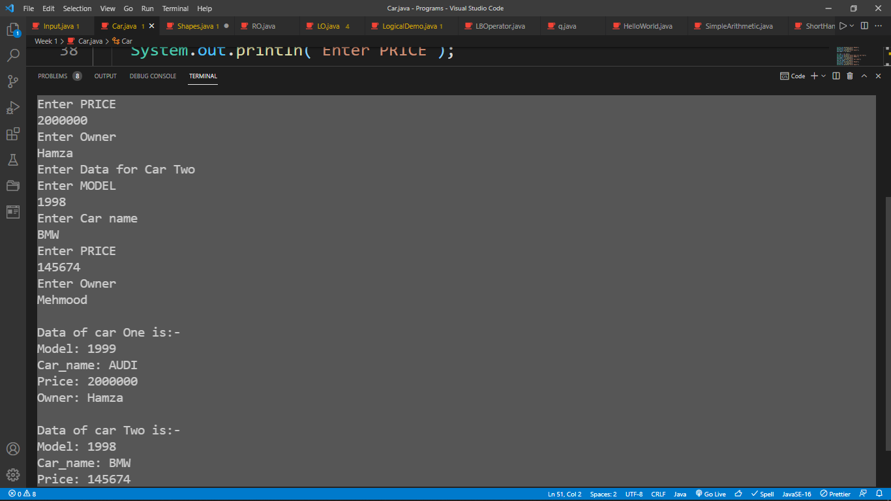

PROGRAM 3

**Source Code:**

package javaapplication28lab.pkg4task2;

class box{

double height;

double width;

double depth;

double voloume(){

return width*height*depth;

}

void setdeimension(double h,double w,double d){

width=w;depth=d;height=h;

}

}

public class JavaApplication28lab4task2 {

public static void main(String[] args) {

box mybox=new box();

box mybox1=new box();

double voloume;

mybox.setdeimension(10, 20, 30);

mybox1.setdeimension(2, 3, 4);

voloume=mybox.voloume();

System.out.println("Voloume of first box is"+voloume);

voloume=mybox1.voloume();

System.out.println("Voloume of second box is"+voloume);

}

}

**Input:**

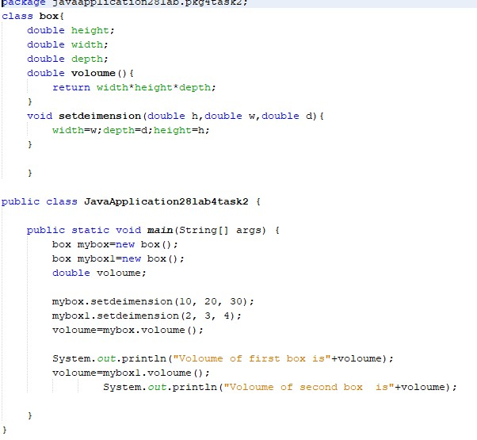

**Output:**

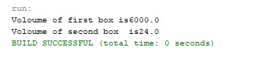

PROGRAM 4

**Source code:**

package javaapplication29.lab.work;

class Test{

int a;

public int b;

private int c;

void Setc(int i){

c=i;

}

int getc(){

return c;

}

}

public class JavaApplication29LabWork {

public static void main(String[] args) {

Test obj=new Test();

obj.a=20;

obj.b=30;

obj.Setc(40);

System.out.println(obj.a+" "+obj.b+" "+obj.getc());

}

}

**Input:**

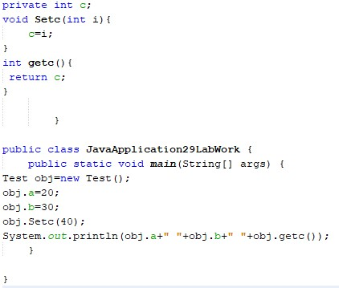

**Output:**

**Question 24 labreportinp.jpg**

PROGRAM 5

package javaapplication36.lab.pkg5.task;

class Distance{

float feet;

float inches;

Distance(){

}

Distance(float f,float i){

this.feet=feet;

this.inches=inches;

}

public float getfeet(){

return feet;

}

public void setfeet(){

this.feet=feet;

}

public float setinches(){

return inches;

}

}

public class JavaApplication36Lab5Task {

public static void main(String[] args) {

Distance Setter=new Distance();

Distance getter=new Distance(10,20);

Distance method=new Distance();

Setter.getfeet();

getter.setfeet();

method.setinches();

}

}

**Input:**

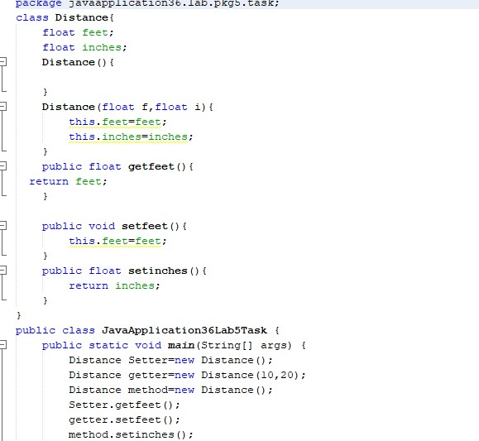

**Output:**

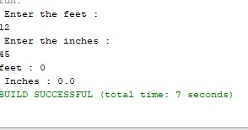

PROGRAM 6

**Source code:**

package javaapplication38.pkgclass.task;

class StaticExample{

static int staticCounter=0;

int counter=0;

StaticExample(){

staticCounter++;

counter++;

}

}

public class JavaApplication38ClassTask {

public static void main(String[] args) {

StaticExample se1=new StaticExample();

StaticExample se2=new StaticExample();

System.out.println("Value of static counter for set1:"+se1.staticCounter);

System.out.println("value of StaticCounter for Se2:"+se2.staticCounter);

System.out.println("value of counter for se1:"+se1.counter);

System.out.println("Value of counter for se2:"+se2.counter);

StaticExample.staticCounter=100;

System.out.println("value of StaticCounter for se1:"+se1.staticCounter);

System.out.println("value of staticCounter for se2:"+se2.staticCounter);

}

}

**Input:**

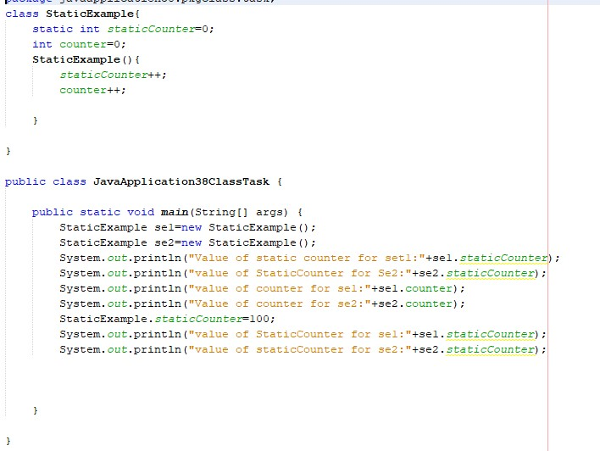

**Output:**

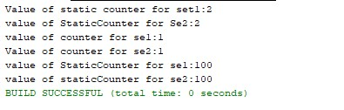

**Program 10:**

package lab.task.java.getter.seeter;

class Adress{

String street;

String house;

String city;

int code;

//now using geetter and setter

void setstreet(String st){

street=st;

}

void sethouse(String h){

house=h;

}

void setcity(String c){

city=c;

}

void setcode(int co){

code=co;

}

String getstreet(){

return street;

}

String gethouse(){

return house;

}

String getcity(){

return city;

}

int getcode(){

return code;

}

}

//Now making the next drieved class

class person extends Adress{

//now method to show adress

void Adress(){

System.out.println("street:"+getstreet());

System.out.println("house:"+gethouse());

System.out.println("city:"+getcity());

System.out.println("code:"+getcode());

}

}

public class LabTaskJavaGetterSeeter {

public static void main(String[] args) {

//now make a object

person p=new person();

p.setstreet("Street #45");

p.sethouse("Jatt jouse");

p.setcity("Islambad");

p.setcode(3456);

p.Adress();

}

}

**Input:**

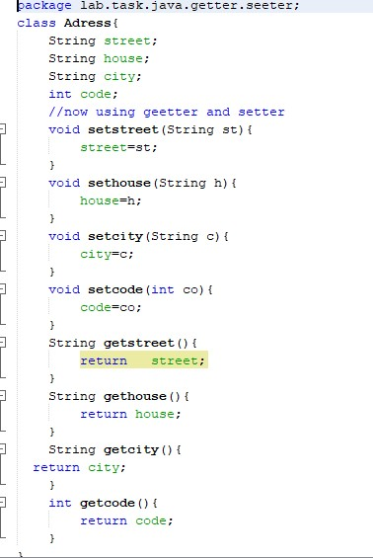

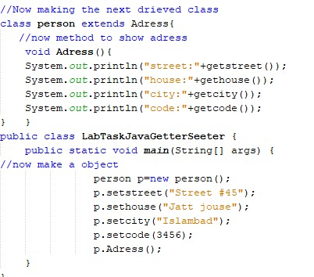

**Output:**

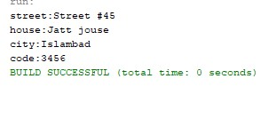

PROGRAM 7

package leture.pkg4.by.mam.practice;

class Box{

double width,height,depth;

Box(Box ob){ //Passing object ot constructor

width=ob.width;

height=ob.height;

depth=ob.depth;

}

Box(double w,double h,double d){

width=w;

height=h;

depth=d;

}

double voloume(){

return width*height*depth;

}

}

public class Leture4ByMamPractice {

public static void main(String[] args) {

Box mybox1=new Box(10,20,30);

Box mybox2=new Box(2,3,3);

double voloume;

voloume=mybox1.voloume();

System.out.println("voloume of the first is"+voloume);

voloume=mybox2.voloume();

System.out.println("Voloume of Second objeext 2 is"+voloume);

}

}

**Input:**

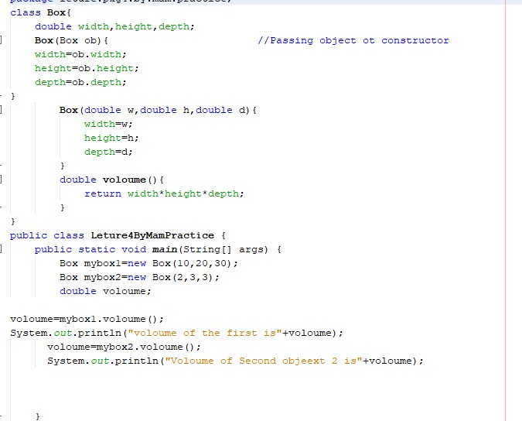

**Output:**

**Question 28abreport inp.jpg**

**Program 12:**

package javaapplication76.lab.pkgclass.work;

import javax.swing.*;

import java.awt.*;

public class JavaApplication76LabClassWork {

public static void main(String[] args) {

JFrame f=new JFrame("this is my first gui program");

JButton b=new JButton("login");

f.add(b);

f.setSize(500, 500);

f.setLayout((new FlowLayout()));

f.setVisible(true);

f.getContentPane().setBackground(Color.yellow);

f.setDefaultCloseOperation(JFrame.EXIT_ON_CLOSE);

}

}

**Input:**

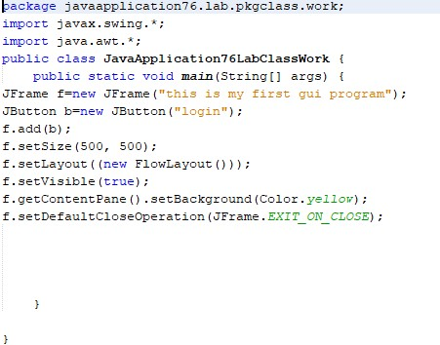

**Output:**

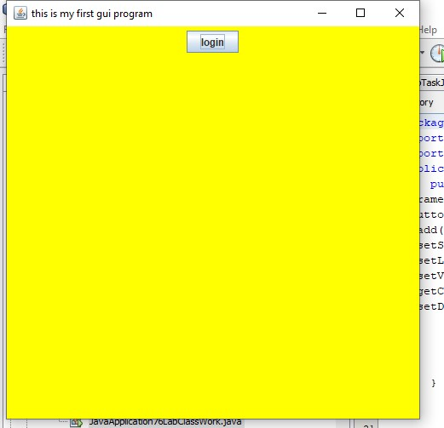

**Program 13:**

package javaapplication77lab.pkgclass.mon.part.pkg2;

import javax.swing.*;

import java.awt.*;

public class JavaApplication77LabClassMOnPart2 {

public static void main(String[] args) {

JFrame f=new JFrame("Gui program");

JLabel L1=new JLabel("user name");

JTextField f1=new JTextField(20);

JLabel l2=new JLabel("Password");

JTextField f2=new JTextField(20);

JButton b=new JButton("login");

f.add(L1);

f.add(f1);

f.add(l2);

f.add(f2);

f.add(b);

f.setSize(500, 500);

f.setLayout((new FlowLayout()));

f.setDefaultCloseOperation(JFrame.EXIT_ON_CLOSE);

f.setVisible(true);

f.getContentPane().setBackground(Color.GREEN);

}

}

**Input:**

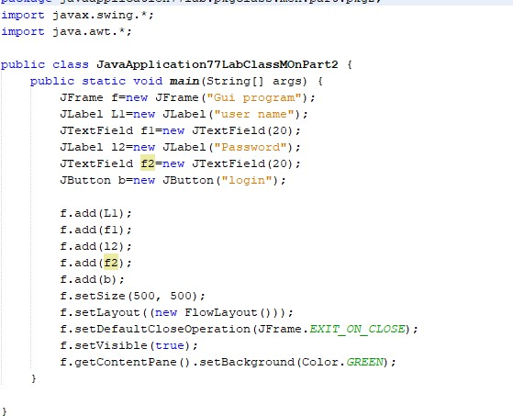

**Output:**

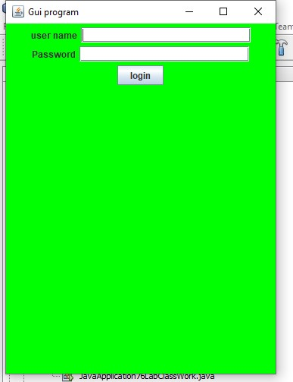

PROGRAM 8

**Source code:**

package layout.labclass;

import javax.swing.*;

import java.awt.*;

class B extends JFrame{

B(){

JButton b1=new JButton("North");

JButton b2=new JButton("south");

JButton b3=new JButton("East");

JButton b4=new JButton("west");

JButton b5=new JButton("cenetr");

add(b1,BorderLayout.NORTH);

add(b2,BorderLayout.SOUTH);

add(b3,BorderLayout.EAST);

add(b4,BorderLayout.WEST);

add(b5,BorderLayout.CENTER);

setSize(500,300);

setVisible(true);

setDefaultCloseOperation(JFrame.EXIT_ON_CLOSE);

}

}

public class LayoutLabclass {

public static void main(String[] args) {

B b1=new B();

}

}

**Input:**

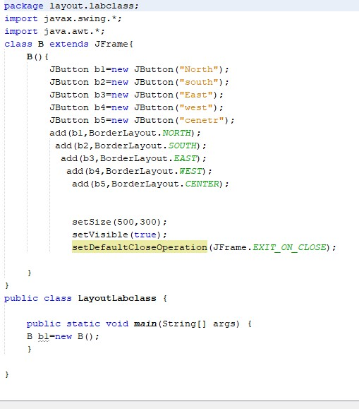

**Output:**

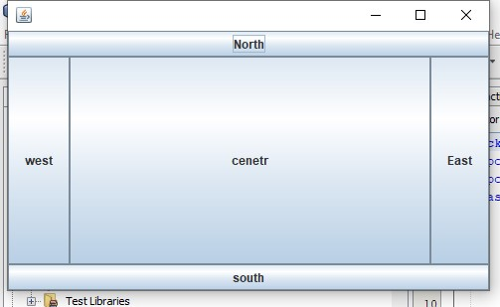

PROGRAM 9

**Source code:**

package grid.layout.lab.pkgclass;

import javax.swing.*;

import java.awt.*;

public class GridLayoutLAbClass {

public static void main(String[] args) {

JFrame f=new JFrame();

JButton b1=new JButton("1");

JButton b2=new JButton("2");

JButton b3=new JButton("3");

JButton b4=new JButton("4");

JButton b5=new JButton("5");

JButton b6=new JButton("6");

JButton b7=new JButton("7");

JButton b8=new JButton("8");

JButton b9=new JButton("9");

f.add(b1);

f.add(b2);

f.add(b3);

f.add(b4);

f.add(b5);

f.add(b6);

f.add(b7);

f.add(b8);

f.add(b9);

f.setLayout(new GridLayout());

f.setSize(1000,500);

f.setVisible(true);

f.setDefaultCloseOperation(JFrame.EXIT_ON_CLOSE);

}

}

**Input:**

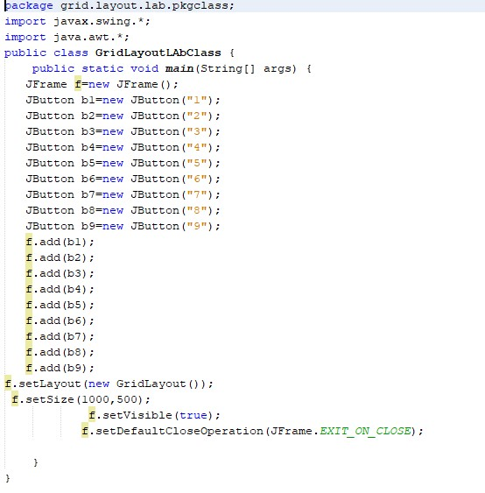

**Output:**

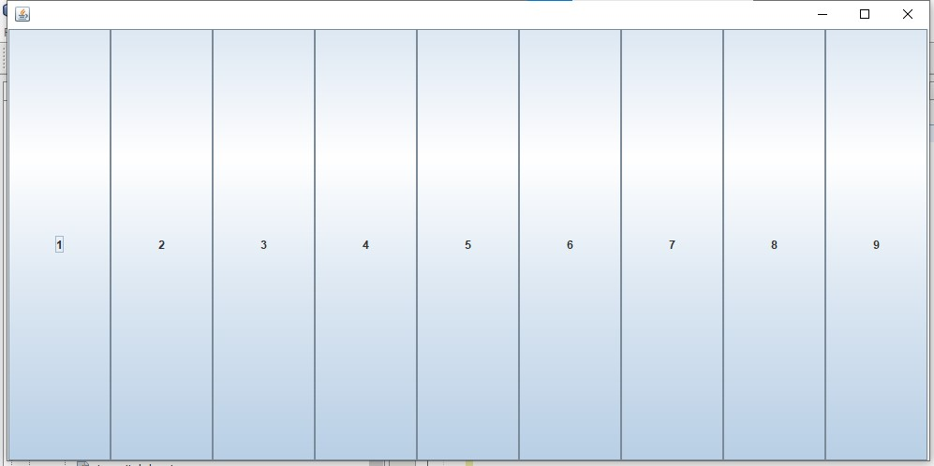

PROGRAM 10

**Source code:**

package boxlayout.lab.pkgclass;

import javax.swing.*;

import java.awt.*;

public class BoxlayoutLabClass {

public static void main(String[] args) {

JFrame f=new JFrame();

JButton b1=new JButton("1");

JButton b2=new JButton("2");

JButton b3=new JButton("3");

JPanel p=new JPanel();

LayoutManager a=new BoxLayout(p,BoxLayout.PAGE_AXIS);

p.add(b1);

p.add(b2);

p.add(b3);

f.getContentPane().add(p);

f.setSize(500,500);

f.setVisible(true);

f.setDefaultCloseOperation(JFrame.EXIT_ON_CLOSE);

}

}

**Input:**

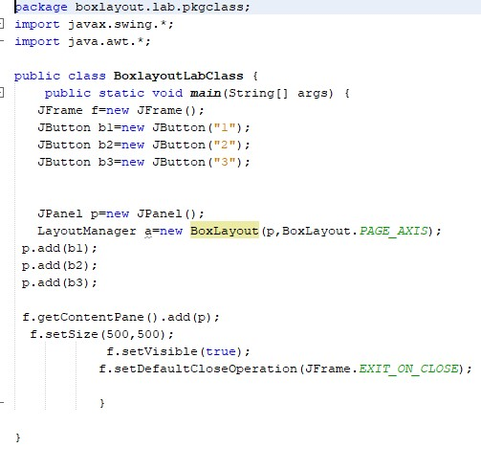

**Output:**

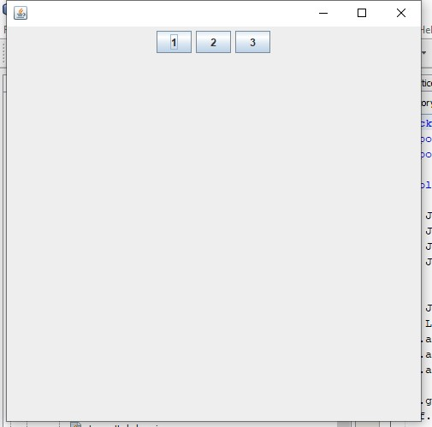

PROGRAM 11

**Source code;**

package componets.layout.pkg2;

import javax.swing.*;

import java.awt.*;

public class ComponetsLayout2 {

public static void main(String[] args) {

JFrame f=new JFrame("compontes using gui");

JLabel l1=new JLabel("First Program");

f.add(l1);

JLabel l2=new JLabel("this is my foirst Gui Gang");

f.add(l2);

l1.setBounds(10, 10, 100, 30);

l2.setBounds(10, 30, 100, 100);

f.setSize(500,500);

f.setVisible(true);

f.setDefaultCloseOperation(JFrame.EXIT_ON_CLOSE);

}

}

**Input:**

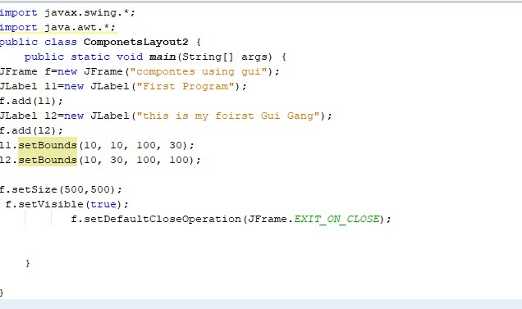

**Output:**

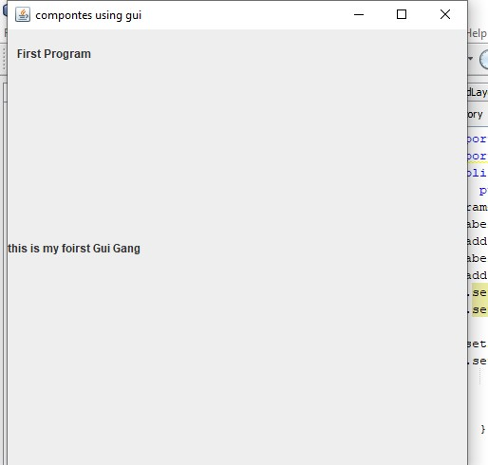

PROGRAM 12

**Source code:**

package componets.layout3;

import javax.swing.*;

import java.awt.*;

public class ComponetsLayout3 {

public static void main(String[] args) {

JFrame f=new JFrame("compontes using gui");

JLabel l1=new JLabel("First Program");

l1.setBounds(10, 10, 100, 30);

f.add(l1);

JLabel l2=new JLabel("this is my foirst Gui Gang");

l2.setBounds(10, 30, 100, 100);

f.add(l2);

JTextField t1=new JTextField("welcome GUI");

t1.setBounds(120, 50, 200, 500);

f.add(t1);

JTextArea ta=new JTextArea("sswing ba DSani");

ta.setBounds(130, 50, 200, 500);

f.add(ta);

f.setSize(500,500);

f.setVisible(true);

f.setDefaultCloseOperation(JFrame.EXIT_ON_CLOSE);

}

}

**Input:**

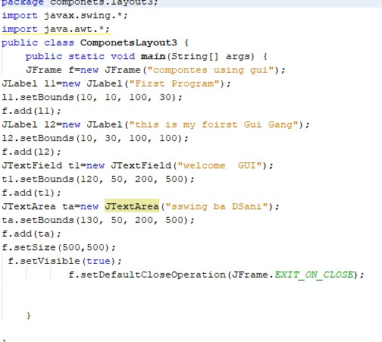

**Output:**

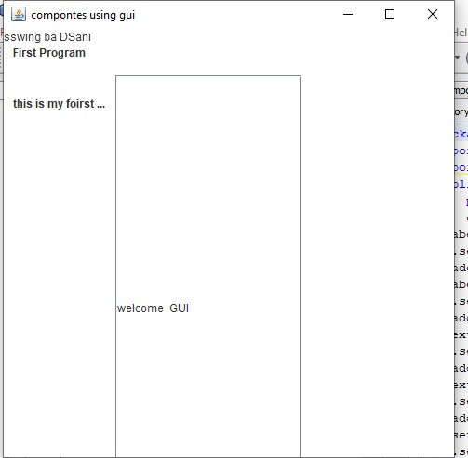

PROGRAM 13

**Source code:**

package componets.layoout;

import javax.swing.*;

import java.awt.*;

public class ComponetsLayoout {

public static void main(String[] args) {

JFrame f=new JFrame();

DefaultListModel<String>l1=new DefaultListModel<>();

l1.addElement("Iteam 1");

l1.addElement("item 2");

l1.addElement("Item 3");

JList<String>list=new JList(l1);

list.setBounds(0, 0, 70, 60);

f.add(list);

JScrollBar j=new JScrollBar();

j.setBounds(100, 100, 50, 40);

f.add(j);

f.setLayout(null);

f.setSize(500,500);

f.setVisible(true);

f.setDefaultCloseOperation(JFrame.EXIT_ON_CLOSE);

}

}

**Input:**

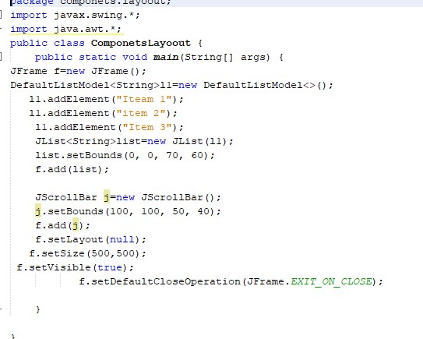

**Output:**

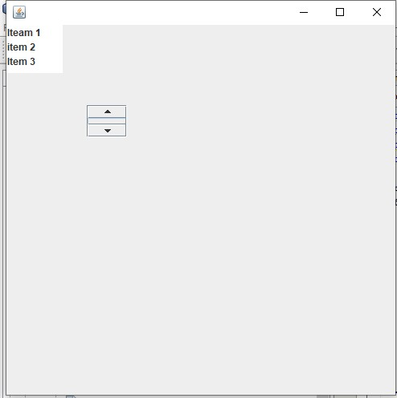

PROGRAM 14

**Source code:**

package labtask.pkgclass.on.tewlve.dec;

import javax.swing.*;

import java.awt.*;

public class LabTaskClassOnTewlveDEC {

public static void main(String[] args) {

JFrame f=new JFrame("login");

JTextField t=new JTextField("User name");

JTextField t1=new JTextField("Sections");

JCheckBox b1=new JCheckBox("jvaa");

JCheckBox b2=new JCheckBox("c++");

JButton b=new JButton("Submit");

f.add(t);

f.add(t1);

f.add(b1);

f.add(b2);

f.add(b);

f.setLayout((new FlowLayout()));

f.setSize(500,500);

f.setVisible(true);

f.setDefaultCloseOperation(JFrame.EXIT_ON_CLOSE);

}

}

**Input:**

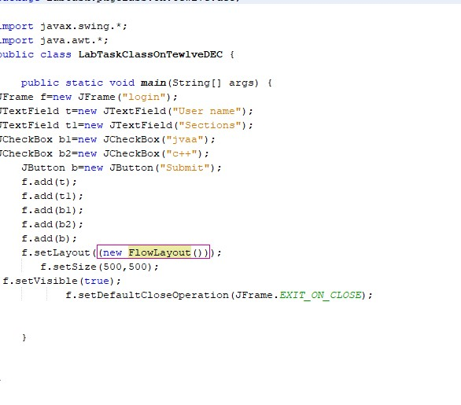

**Output:**

